Obstetrics Overseas: my month in Fiji

Exactly a week after completing my medical school finals, I found myself being shown around the maternity unit of the Colonial War Memorial (CWM) Hospital in Suva, Fiji. Eager to immerse myself in the new healthcare environment, I was warmly welcomed by my new colleagues and embraced the opportunity to learn from them.

Throughout my month-long attachment, I gained valuable hands-on experience and encountered a diverse range of medical conditions seen less commonly in the UK. Several differences stood out compared to my university placements: the physical environment, patient-doctor dynamics, and my role within the system.

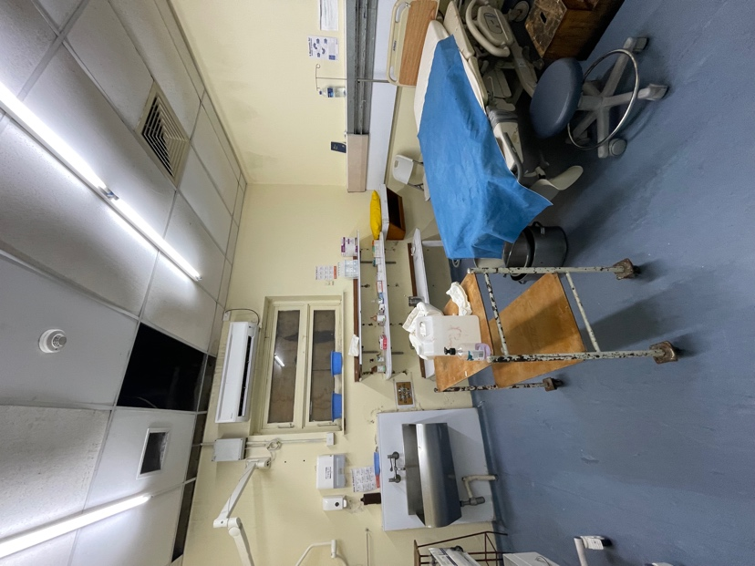
Coming from a cold wet English February, I was immediately struck by how cramped and stifling the wards were. Privacy was limited, with communal areas for women in their first stage of labour. Here they would stay until they were 10cm dilated, before being asked to walk (or hobble) to a delivery room (if available). Partners were not permitted to attend their child’s birth, mainly so as not to make neighbouring women feel uncomfortable. Resource constraints impacted the options available to patients; women did not have access to epidurals, nor could they choose to have a caesarean section, as with only 3 operating rooms for the entire hospital, only emergencies stood a chance of justifying the theatre time.
One of the four delivery rooms in the maternity unit

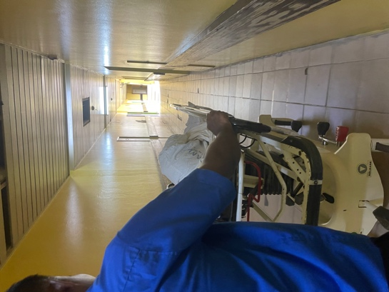
Medical practice displayed a slightly more paternalistic approach, with doctors’ advice at least somewhat influenced by resource availability and system constraints. Unlike the hyper-specialization in the UK, Fijian doctors operate as generalists, each managing a wider range of conditions with fewer diagnostic tools. However, the most significant difference between my elective experience and my UK O&G placement was the level of hands-on involvement. With the guidance of incredibly kind and experienced midwives, I learnt how to monitor and support a woman through labour, deliver her baby and placenta safely and suture lacerations. Having seen only two vaginal deliveries in my seven-week placement in the UK, I delivered over ten babies in Fiji, an experience I will never forget. I practiced cannulation, did vaginal examinations, assisted in C-sections, and learnt basic foetal ultrasound scanning in clinic. I am hugely grateful for these opportunities and skills I have walked away with, which I’m certain will be incredibly valuable in my future O&G career.
It took about 10 minutes to walk from the labour ward to theatres in an emergency

I also encountered several conditions and procedures that I hadn’t previously had exposure to at home. I assisted with an open hysterectomy, bilateral salpingectomy, and uterine polyp removal - an excellent opportunity to see the full pelvic anatomy. I cared for several pre-eclamptic woman and supported a woman through miscarriage. I witnessed the horror of a stillbirth, just minutes after assisting in the delivery of a healthy baby in the same room. I watched as the midwifery staff seamlessly switched gears and adjusted to the emergency but was struck by an obvious lack of preparedness that I know I wouldn’t have seen at home. It felt like minutes before a bag-valve-mask was located and a paediatric registrar notified. I couldn’t help but feel uneasy knowing how much better the situation could have been managed with a properly equipped resuscitaire and better staffing availability.

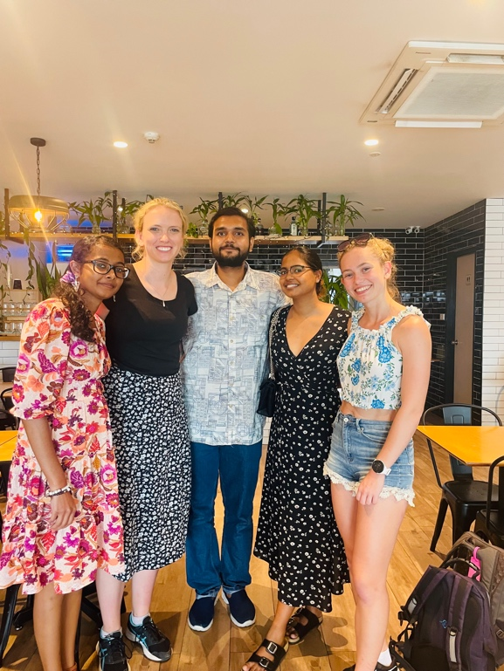
As well as being a brilliant practical experience, this elective helped me appreciate the broader societal role of O&G clinicians, particularly in addressing cultural influences on women’s health decisions. Their vital educational role was especially pertinent in areas such as family planning and cervical smears, where juxtaposing cultural beliefs were particularly influential. I also noticed how the position of women in society fed into the style of care that was customary for clinicians to deliver. I felt that there were occasional lapses in confidentiality, privacy, and respect, highlighting a need for ongoing improvements in patient care.
Lunch with some of the lovely medical students we met on O&G

Overall, I thoroughly enjoyed my four weeks of O&G at CWM. It was a hugely rewarding experience that has reinforced my passion for obstetric medicine. Working alongside friendly and dedicated staff, I not only expanded my clinical skills, but also gained a deeper understanding of the societal factors shaping women’s health outcomes. Moving forward, I am excited to apply the knowledge and insights gained from my elective in Fiji to my future career in obstetrics and gynaecology.

